For fertility rate and Life expectancy Dashboard
Analyzing the visual tab of dashboard(Problem 2)
Which country in Europe had the highest fertility rate for its continent in 1980, but gradually changed to have the lowest fertility rate.?
Poland
In 1980: Poland had highest fertility rate:
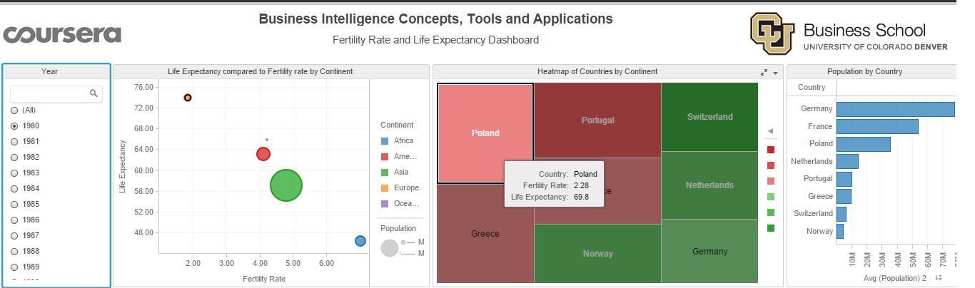
In 2007: Poland has lowest fertility rate:
